NAME: K Yamini
REG NO: 192572181

Write a Prolog program to print whether a particular bird can fly or not. Incorporate required queries.
Aim:
To write a Prolog program that determines whether a particular bird can fly or cannot fly using facts and rules.
Algorithm:
- Start the program.
- Define facts for birds that can fly.
- Define facts for birds that cannot fly.
- Define the rule can_fly(Bird).
- Give a query for a particular bird.
- Prolog checks the facts and rules.
- If the bird can fly, display can fly.
- Otherwise, display cannot fly.
- Stop the program.
Prolog program:
% EXPERIMENT 23
% Bird Can Fly or Not

% Facts
bird(parrot).
bird(eagle).
bird(pigeon).
bird(ostrich).
bird(penguin).

% Birds that can fly
flies(parrot).
flies(eagle).
flies(pigeon).

% Birds that cannot fly
cannot_fly(ostrich).
cannot_fly(penguin).

% Rule to check whether a bird can fly
can_fly(Bird) :-
flies(Bird).

% Rule to check whether a bird cannot fly
not_fly(Bird) :-
cannot_fly(Bird).

% Display result
check_bird(Bird) :-
can_fly(Bird),
write(Bird),
write(' can fly.'),
nl.

check_bird(Bird) :-
not_fly(Bird),
write(Bird),
write(' cannot fly.'),
nl.
Input:
?- check_bird(parrot).
Output :
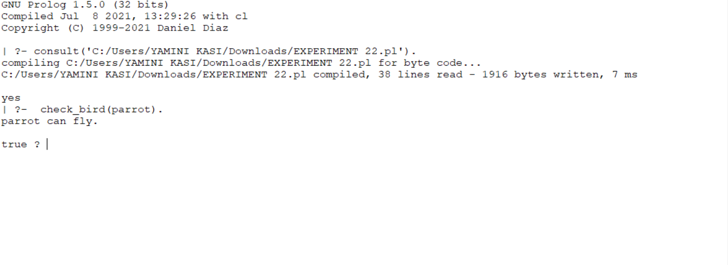
Result:
Thus, the Prolog program was successfully implemented to determine whether a particular bird can fly or not using facts, rules, and queries.

